Explainable AI for Thyroid Cancer Detection using Smartphone-captured Cytopathology Images and Multi-Instance Learning
Quan Thanh Huynh, Hieu Xuan Le, Lien Tran, Trung Nguyen, Luan Nguyen, Alex Mremi, Daniel Mbwambo, Walter Lee^{1†}, Hoan Thanh Ngo^{2†}
¹Duke University Medical Center, Durham, NC, USA
²Florida Southern College, Lakeland, FL, USA

We report an explainable AI model for thyroid cancer detection using multi-instance learning and cytopathology images captured by smartphone.

Introduction: Digital pathology where slide images are digitized is transforming the traditional pathology. This is because digitized images can be quickly accessed, shared, and analyzed,. It allows remote clinical case diagnosis and application of advanced image analysis algorithms, including AI-based algorithms. These revolutionary algorithms can potentially support doctors in diagnosis and treatment and improve clinical care and outcomes. However, digitizing slides requires expensive scanners costing up to $250,000, a great cost barrier for many clinical centers in LMICs. With lack of equipment, people living in LMICs, especially outside big cities, are not benefiting from the advancements in the field. Our group previously proposed a low-cost smartphone-based digitizing approach for capturing cytopathology slide images followed by AI-powered analysis for thyroid cancer detection with accuracy of 96% on smartphone images collected at Duke Hospital, USA. In this work, we tested the approach in two LMICs countries, Vietnam and Tanzania, and made two main contributions including: (1) propose an AI model based on EfficientNet that can accurately predict malignancy from smartphone-captured cytopathology images from Vietnam and Tanzania with accuracy of 95% and 88% respectively, (2) the model’s predictions are presented with heatmaps showing the regions that important to the model’s predictions, providing explainability to our models’ predictions (Figure 1). Explainability in AI model’s predictions is important for gaining trust from user and successful deployment of AI models in medicine (cite xAI paper). We believe that our smartphone and AI-based approach have the potential to be integrated in clinical workflow in LMICs to improve thyroid cancer clinical care and outcomes in these countries. The approach can also be applied for other cancer types.

Materials and Methods: Data were collected from the National ENT Hospital in Hanoi, Vietnam, and the Kilimanjaro Christian Medical Center (KCMC) in Moshi, Tanzania. The Vietnam site used alcohol-fixed stain while the Tanzania site used Pap stain. In both sites, cytopathology slide images were captured by Redmi Note 10S mobile phone cameras (Xiaomi Inc) attached to optical microscopes. In total, 2,048 smartphone images from 132 patients were collected from Vietnam site, and 1,119 images from 100 patients from Tanzania site. Images from Vietnam site have resolution of 2080 x 4624 px while from the Tanzania dataset 3072 x 4096 px. The images were resized and crop to 224 x 224 px and divided into a training set (70% of patients) and a testing set (30% of patients) in patient-preserved manner. All patients have cytopathologist diagnosis and surgical diagnosis with a few exception. We used surgical diagnosis, malignant or benign, of each patient to assign label for all images belong to the patient (i.e., weakly supervision). Due to different staining methods and optical equipment, image characteristics from the two sites were noticeably different from each other and from Duke Hospital’s smartphone-captured slide images. We therefore independently trained and test two AI models based on Efficient-b0 architecture (https://arxiv.org/pdf/1905.11946) with ImageNet pretrain weights on Vietnam images and Tanzania images. The models were trained on a local machine for 100 epochs using PyTorch framework. Data augmentation including random crop and flip were using during training. CrossEntropyLoss and Adam were used as loss function and optimizer respectively.

Results And Discussion: For Vietnam data, the AI achieved 95% accuracy and 95% weighted average F1-score with 97% sensitivity and 89% specificity during testing. For Tanzania data, the AI achieved 88% accuracy and 90% weighted average F1-score with 100% sensitivity and 87% specificity of during testing. We attempted to explain the models’ predictions using an Occlusion-based approach and Captum library (link to Captum website). The results showed that for most of the images, the models correctly looked at cell regions when making predictions. AI models often lack explainability, a problem commonly known as “black box” issue. Without explanation, user tend to less trust on AIs’ predictions, which in turn could hinder AI deployment in clinical workflow. Our models exhibit high accuracy on data collected from two LMICs, Vietnam and Tanzania, and their predictions can be explained via heat maps highlighting the regions that are important to model’s predictions. This approach is promising and have potential to improve thyroid cancer diagnosis in LMICs.
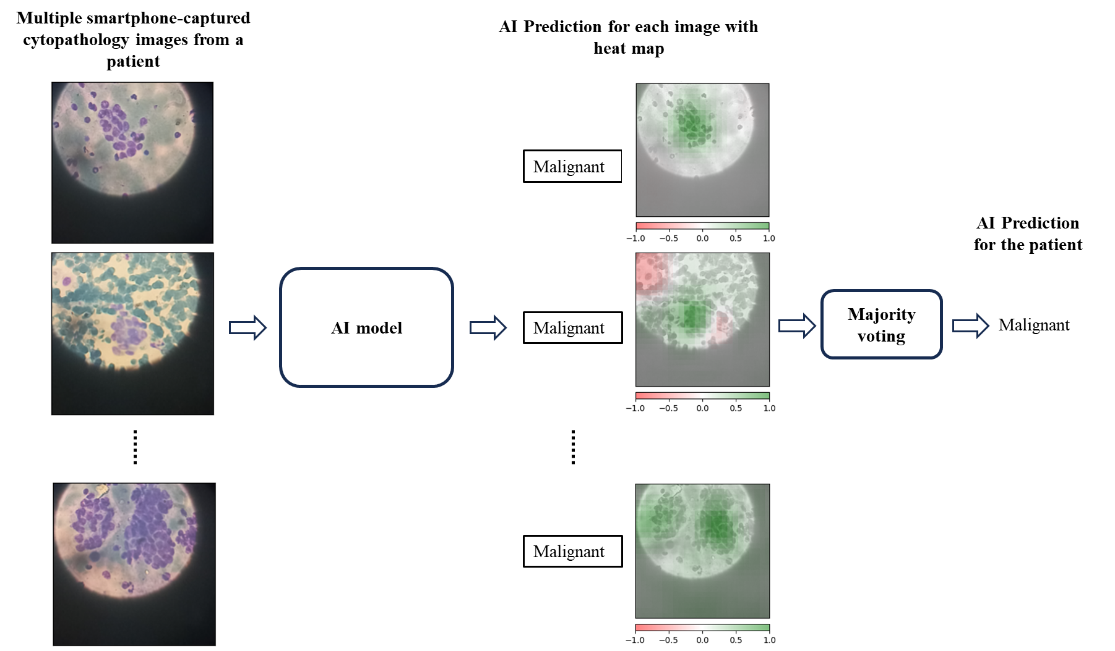
Figure 1: Explainable AI based on multi- instance learning for thyroid cancer detection from cytopathology images captured by smartphone. Multiple images from a patient were sequentially input into an AI model that output prediction for each input image together with heatmap showing the region(s) that are important to AI’s prediction. The predictions were combined using majority voting to create a final prediction for the patient.

Conclusions: In this work, we report AI models for thyroid cancer detection smartphone-captured cytopathology images collected from two LMICs, Vietnam and Tanzania. The model exhibit 95% and 88% accuracies when test on Vietnam and Tanzania data, respectively. The models’ predictions can be explained via heatmaps highlighting regions at which the models are looking.

Acknowledgements: The authors graciously acknowledge funding from the National Institutes of Health (1R21CA268428-01 NC)).
†Corresponding author: Professor Walter Lee, email: walter.lee@duke.edu and Professor Hoan T. Ngo, email: hngo@flsouthern.edu

